- Console "Hello Word" in document.ready function
A1.
1.html
<html lang="en-IN">
<head>
<meta charset="utf-8">
<title>Question 1</title>
</head>
<body>
<script type="text/javascript" src="jquery.min.js"></script>
<script>
$(document).ready(function() {
console.log('Hello World');
});
</script>
</body>
</html>

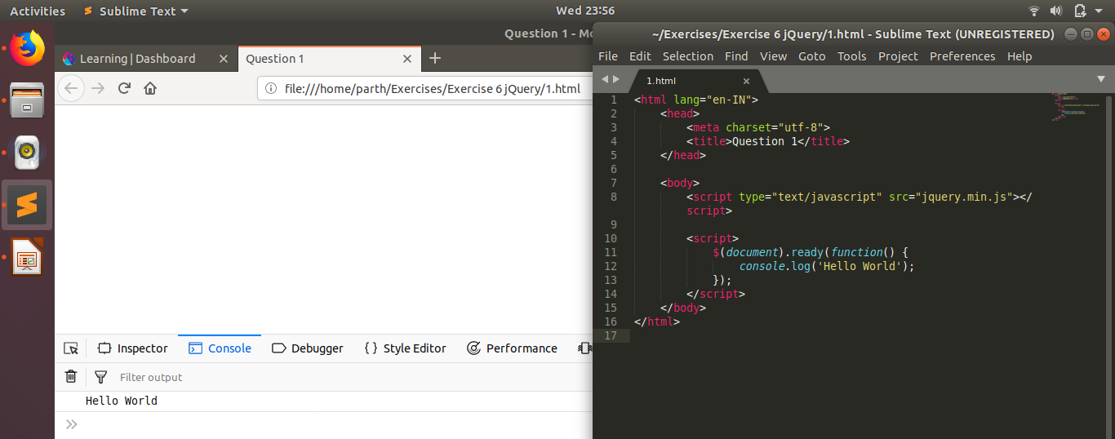

- Select a ID name "#test" and add class "load" when DOM is loaded
A2.
2.html
<html lang="en-IN">
<head>
<meta charset="utf-8">
<title>Question 2</title>
<style>
.load{
text-align: center;
}
</style>
</head>
<body>
<p id = 'test'>Hi</p>
<script type="text/javascript" src="jquery.min.js"></script>
<script>
$(document).ready(function() {
$('#test').addClass('load');
});
</script>
</body>
</html>

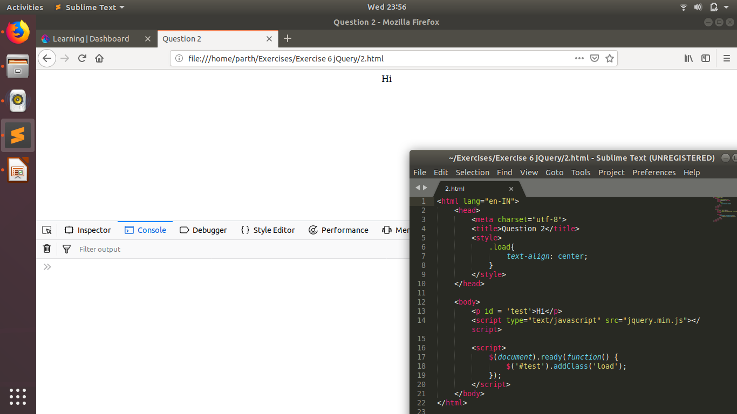
- Change the color of element which class name end with "-new"
A3.
3.html
<html lang="en-IN">
<head>
<meta charset="utf-8">
<title>Question 3</title>
</head>

<body>
<p class = 'abc-new'>This has class <q>-new</q></p>
<p class = 'new'> This doesn't have class <q>-new</q></p>

<script type="text/javascript" src="jquery.min.js"></script>
<script>
$(document).ready(function() {
$("[class$='-new']").css('color', 'red');
});
</script>
</body>
</html>

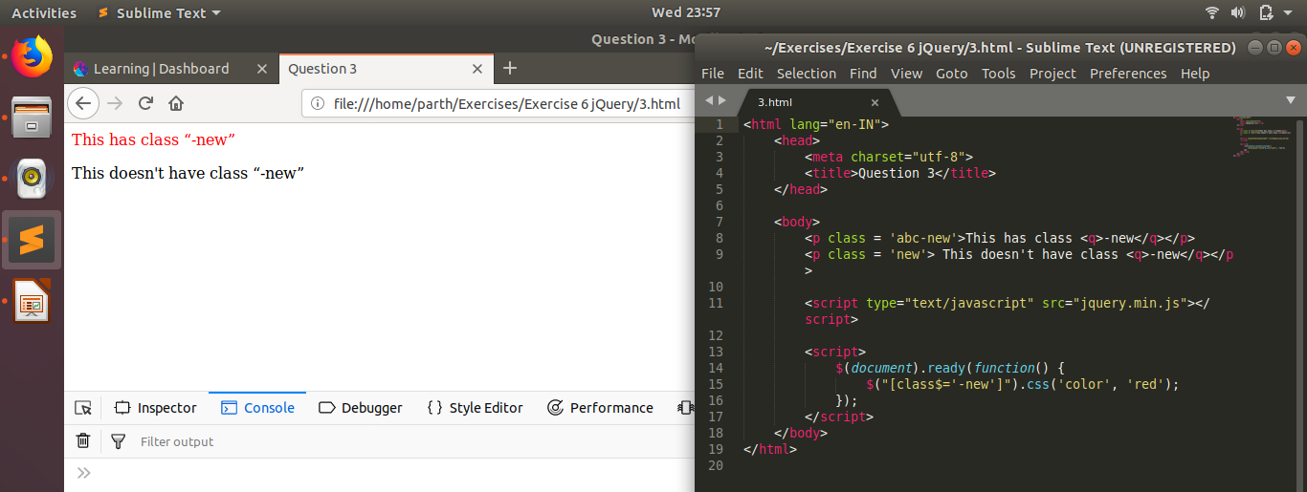

- Disable submit button using jquery attr method
A4.
4.html
<html lang="en-IN">
<head>
<meta charset="utf-8">
<title>Question 4</title>
</head>
<body>
<button>Click Me!</button>

<script type="text/javascript" src="jquery.min.js"></script>
<script>
$(document).ready(function() {
$('button').attr('disabled', true);
});
</script>
</body>
</html>

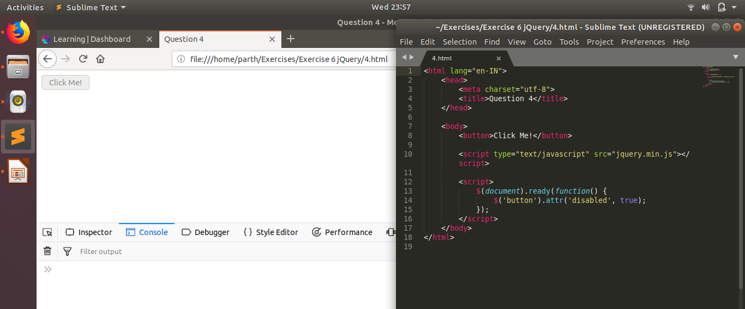

- Change the font size of ".target" which has parent element with id name "#main"
A5.
5.html
<html lang="en-IN">
<head>
<meta charset="utf-8">
<title>Question 5</title>
</head>

<body>
<div id = "main">
<p class = "target">1</p>
<p>2</p>
</div>

<div id = "abc">
<p class = "target">3</p>
<p>4</p>
</div>

<script type="text/javascript" src="jquery.min.js"></script>
<script>
$(document).ready(function() {
$('#main > .target').css('font-size', '50');
});
</script>
</body>
</html>

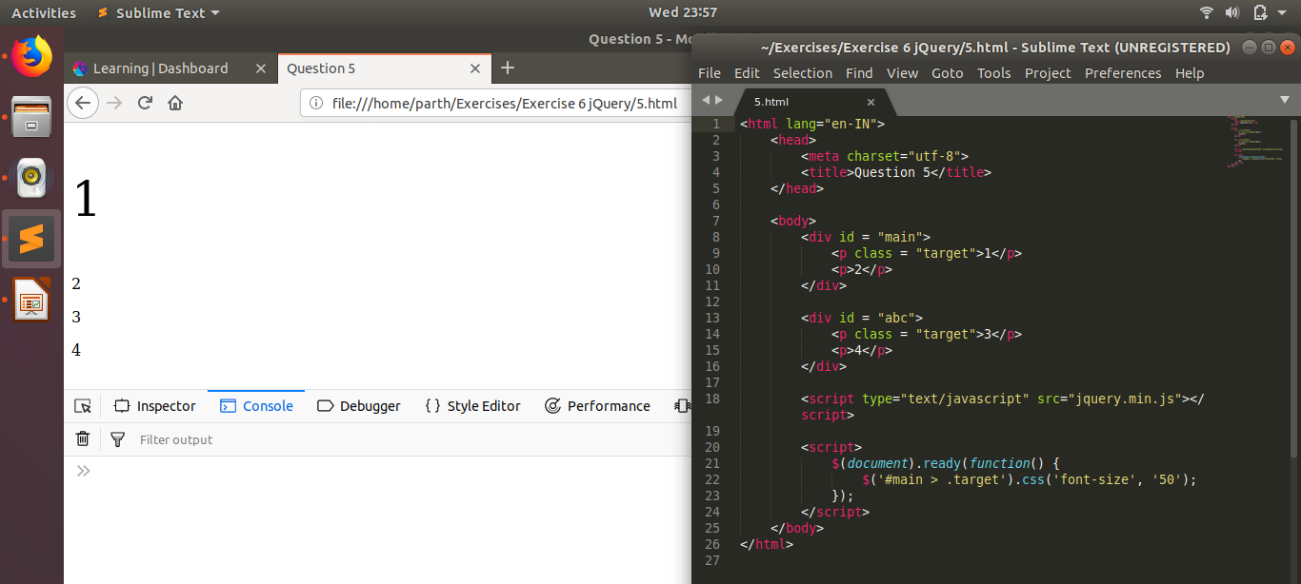
- After page load change the HTML of div element with "p" element
A6.
6.html
<html lang="en-IN">
<head>
<meta charset="utf-8">
<title>Question 6</title>
</head>
<body>
<div id = "main">This is div element</div>
<p class = "target">This is p element</p>

<script type="text/javascript" src="jquery.min.js"></script>
<script>
$(document).ready(function() {
var ele = $('p').clone();
$('div').html(ele);
});
</script>
</body>
</html>

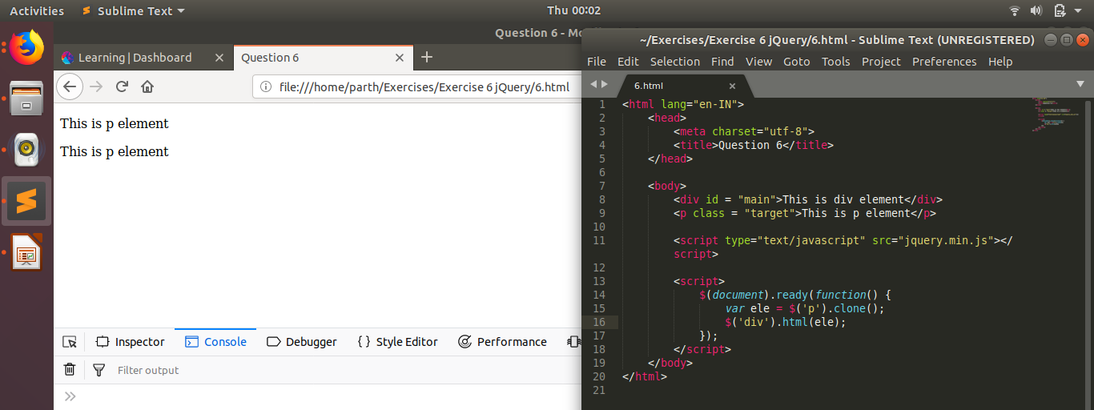
- Bind a click function to an "click" element and append next "click" next to it.
A7.
7.html
<html lang="en-IN">
<head>
<meta charset="utf-8">
<title>Question 7</title>
</head>
<body>
<p class = "click">Click me</p>

<script type="text/javascript" src="jquery.min.js"></script>
<script>
$(document).ready( function() {
function clicked(){
var ele = $(".click:first").clone();
$('.click:last').after(ele);
}

$('.click').click(clicked);
});
</script>
</body>
</html>
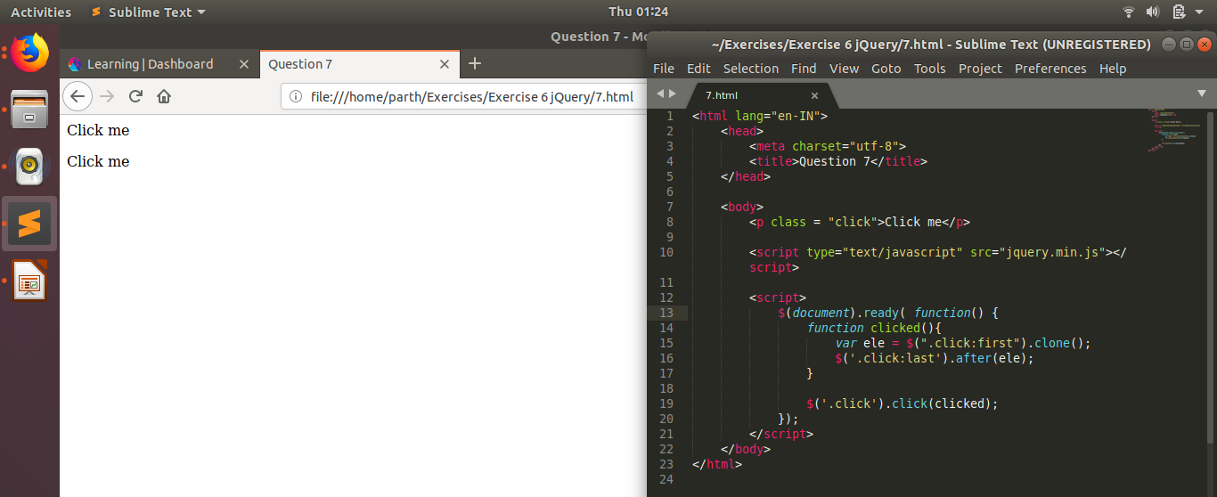

- Click event not working on element which added dynamicly or via script, make it work using .on method
A8.
8.html
<html lang="en-IN">
<head>
<meta charset="utf-8">
<title>Question 8</title>
</head>
<body>
<p class = "click">Click me</p>

<script type="text/javascript" src="jquery.min.js"></script>
<script>
$(document).ready( function() {
function clicked(){
var ele = $(".click:first").clone();
$('.click:last').after(ele);
}

$('body').on('click', '.click', clicked);
});
</script>
</body>
</html>
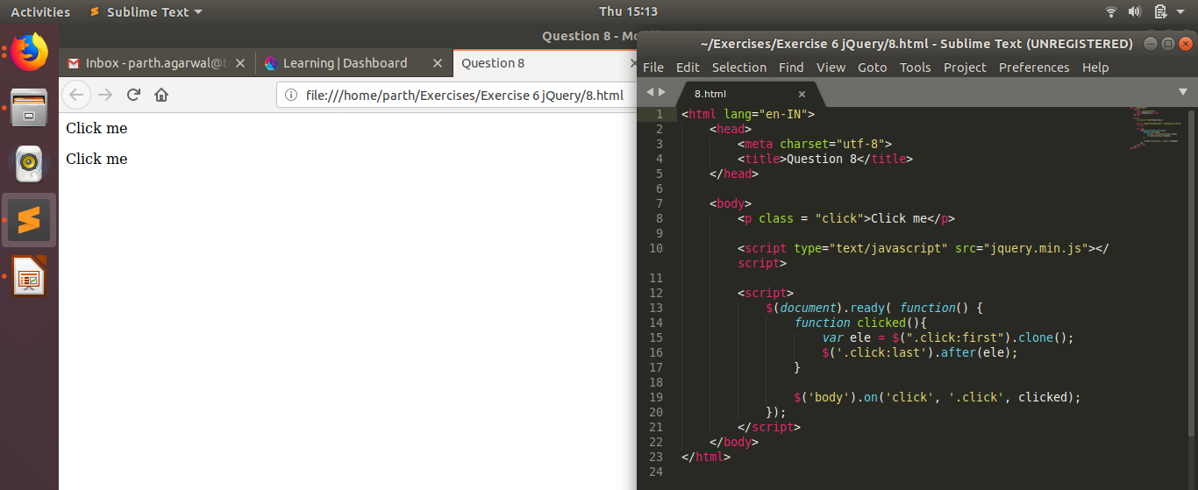

- Get dropdown selected value on onchanage event and append in div container
A9.
9.html
<html lang="en-IN">
<head>
<meta charset="utf-8">
<title>Question 9</title>
</head>
<body>
<div>
<select>
<option value = "opt1">Option 1</option>
<option value = "opt2">Option 2</option>
</select>
</div>

<script type="text/javascript" src="jquery.min.js"></script>
<script>
$(document).ready( function() {
function appendoption(){
var e = $('select :selected');
$('select :selected').closest('div').append('<br>' + e.text());
}
$('select').on('change', appendoption);
});
</script>
</body>
</html>
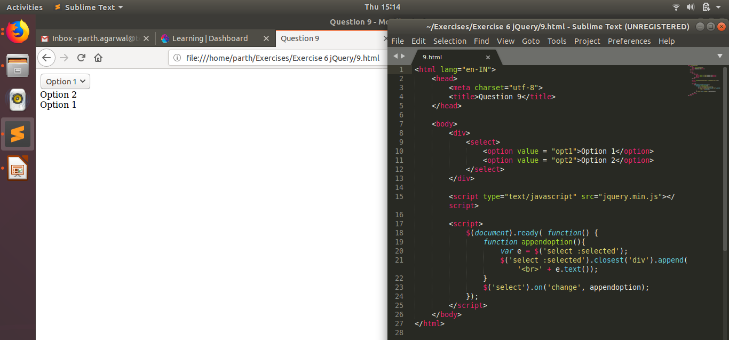

- Create a dropdown menu using hover method in jquery
A10.
10.html
<!DOCTYPE html>
<html>
<head>
<meta charset="utf-8">
<style>
#dropdown {
position: absolute;
}
#dropbtn {
background-color: #000;
color: white;
padding: 16px;
font-size: 16px;
border: none;
position: relative;
box-sizing: border-box;
}
#dropdown-content {
display: none;
width: 100%;
text-align: center;
background-color: #eee;
}
a {
color: black;
padding: 12px 16px;
text-decoration: none;
display: block;
}
</style>
</head>
<body>
<div id="dropdown">
<button id="dropbtn">Dropdown</button>
<div id="dropdown-content">
<a href="#">1</a>
<a href="#">2</a>
<a href="#">3</a>
</div>
</div>

<script type="text/javascript" src="jquery.min.js"></script>
<script>
$(document).ready(function(){
$('#dropdown').hover(function(){
$('#dropdown-content').slideToggle();
});
});
</script>
</body>
</html>

- On clicking on "google" tag. It is taking us to google home page. Stop it from happening.
A11.
11.html
<html lang="en-IN">
<head>
<meta charset="utf-8">
<title>Question 11</title>
</head>
<body>
<a href = "https://www.google.com/">google</a>

<script type="text/javascript" src="jquery.min.js"></script>
<script>
$(document).ready( function() {
$('a').on('click', function(e){
e.preventDefault();
});
});
</script>
</body>
</html>
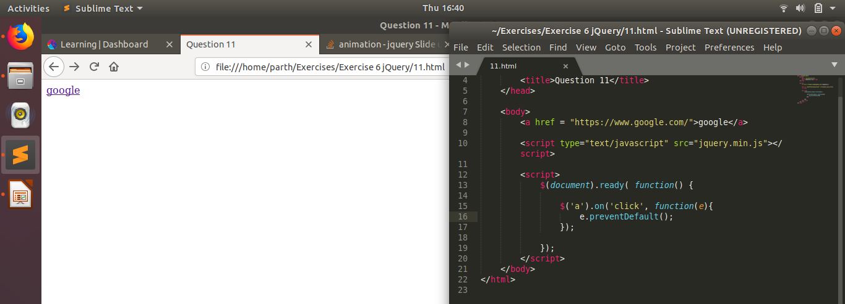

- We have bind a click funtion to parent div but we want stop it from performing when user clicks on its child li
A12.
12.html
<html lang="en-IN">
<head>
<meta charset="utf-8">
<title>Question 12</title>
</head>
<body>
<div>
<ul>
<li>1</li>
<li>2</li>
</ul>
</div>

<script type="text/javascript" src="jquery.min.js"></script>
<script>
$(document).ready( function() {

$('li').click(function(e){
$('li').css('color', 'red');
e.stopPropagation();
})

$('div').click(function(){
$('div').css('background-color', 'green');
})
});
</script>
</body>
</html>
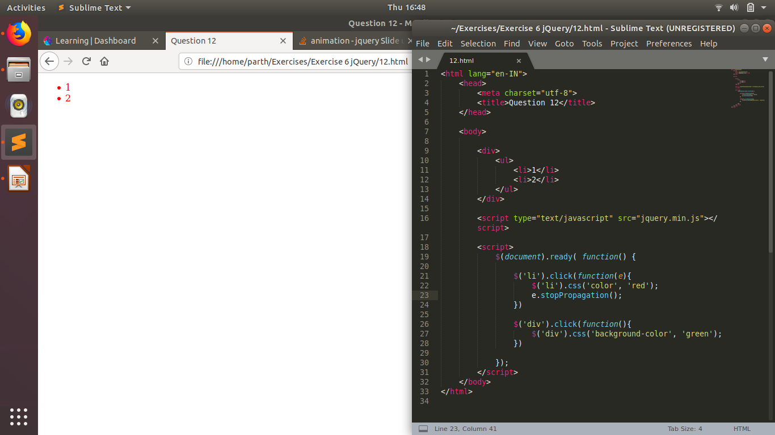
- Get the max height of elements using jquery each method
A13.
13.html
<html lang="en-IN">
<head>
<meta charset="utf-8">
<title>Question 13</title>
</head>
<body>
<div>
<p>abc</p>
<h1>Heading 1</h1>
</div>
<div>
<h2>Heading 2</h2>
<p>def</p>
</div>

<script type="text/javascript" src="jquery.min.js"></script>
<script>
$(document).ready( function() {

var max_height = 0;
$('body').children().each(function(){
console.log($(this));
if($(this).height() > max_height){
max_height = $(this).height();
}
});

alert("Max height of elements is: " + max_height);
});
</script>
</body>
</html>
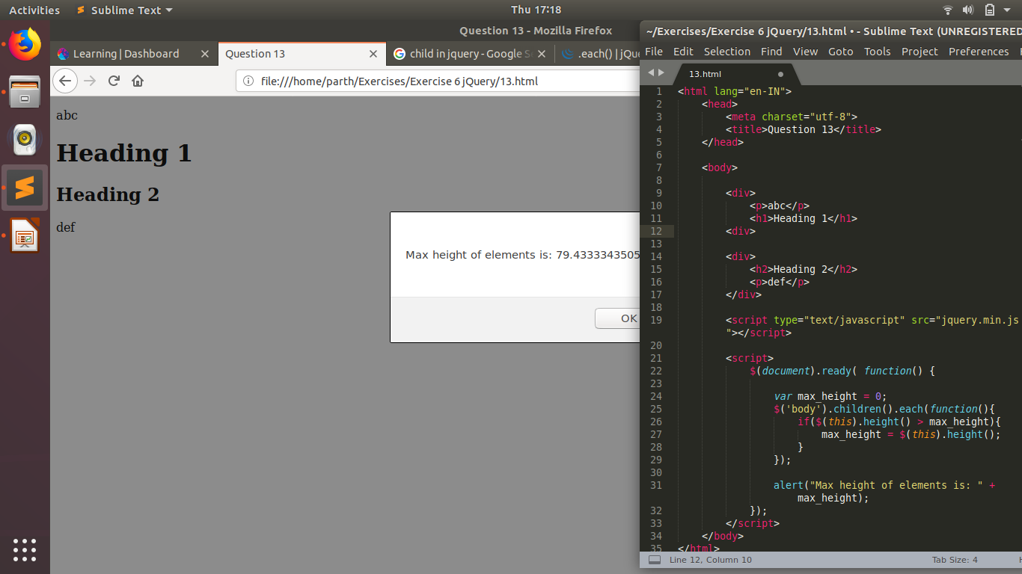

- Chagne color of every cell which has numberl larger than 10.
A14.
14.html
<html lang="en-IN">
<head>
<meta charset="utf-8">
<title>Question 14</title>
<style>td{text-align: center;}</style>
</head>
<body>
<table style="width:100%">
<tr>
<th>Height</th>
<th>Weight</th>
<th>Age</th>
</tr>
<tr>
<td>130</td>
<td>5</td>
<td>5</td>
</tr>
<tr>
<td>9</td>
<td>11</td>
<td>94</td>
</tr>
</table>

<script type="text/javascript" src="jquery.min.js"></script>

<script>
$(document).ready( function() {

$('td').each(function(){
if($(this).text() > 10){
$(this).css('color', 'red');
}
});
});
</script>
</body>
</html>

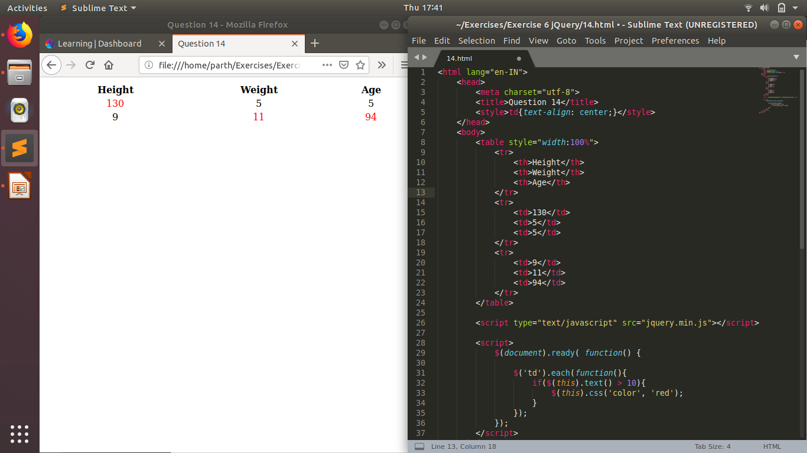
- Retrive the data from server using ajax get call
A15.
15.html
<html lang="en-IN">
<head>
<meta charset="utf-8">
<title>Question 15</title>
<style>td{text-align: center;}</style>
</head>
<body>
<button>Click me to do an AJAX call</button>

<script type="text/javascript" src="jquery.min.js"></script>
<script>
$(document).ready(function(){
$('button').click(function(){
$.ajax({
url: "15.xml",
success: function(result){
console.log(result);
}
});
});
});
</script>
</body>
</html>

15.xml
<abc>
</abc>

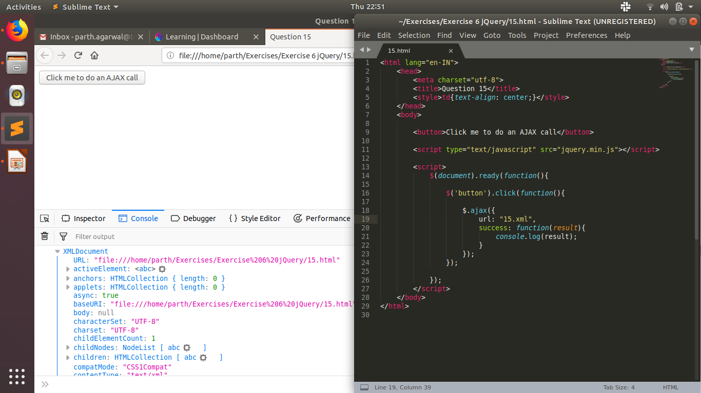
- Add cross button on row and bind click function which make a delete request to server, after success event remove the row from dom
A16.
16.html
<html lang="en-IN">
<head>
<meta charset="utf-8">
<title>Question 16</title>
<style>table, td, th{text-align: center; border: 2px solid black; border-collapse: collapse;}</style>
</head>
<body>

<script type="text/javascript" src="jquery.min.js"></script>
<script>
var xml;

function delrow(e){
idx = e.closest('tr').rowIndex - 1;

data = xml.getElementsByTagName('data')[0];

xml.documentElement.removeChild(data.children[idx]);

$.ajax({
url: "16.xml",
method: "POST",
contentType: "application/xml; charset=utf-8",
data: xml.getElementsByTagName('data')[0].outerHTML,
success: function(){
alert('Row successfully deleted from file on server');
}
});

e.closest('tr').remove();
}

$(document).ready( function() {

$.ajax({
url: "16.xml",
type: "GET",
success: function(result){

xml = result;
var table = "<table style='width: auto'><tbody>";

$('data', xml).children().each(function(i){
table += '<tr>';
if(i == 0){
cellTag = 'th';
buttonColumn = '<th>Delete</th>';
}
else{
cellTag = 'td';
buttonColumn = '<td><button onclick="delrow(this)">X</button></td>';
}

var row = $(this);
row.children().each(function(){
table += '<' + cellTag + '>' + $(this).text() + '</' + cellTag + '>';
});

table += buttonColumn;
table += '</tr>';

});

table += "</tbody></table>";
$('body').prepend(table);
}
});
});
</script>
</body>
</html>

16.xml
<data>
<row>
<cell>Height</cell>
<cell>Weight</cell>
<cell>Age</cell>
</row>
<row>
<cell>130</cell>
<cell>5</cell>
<cell>5</cell>
</row>
<row>
<cell>9</cell>
<cell>11</cell>
<cell>94</cell>
</row>
</data>
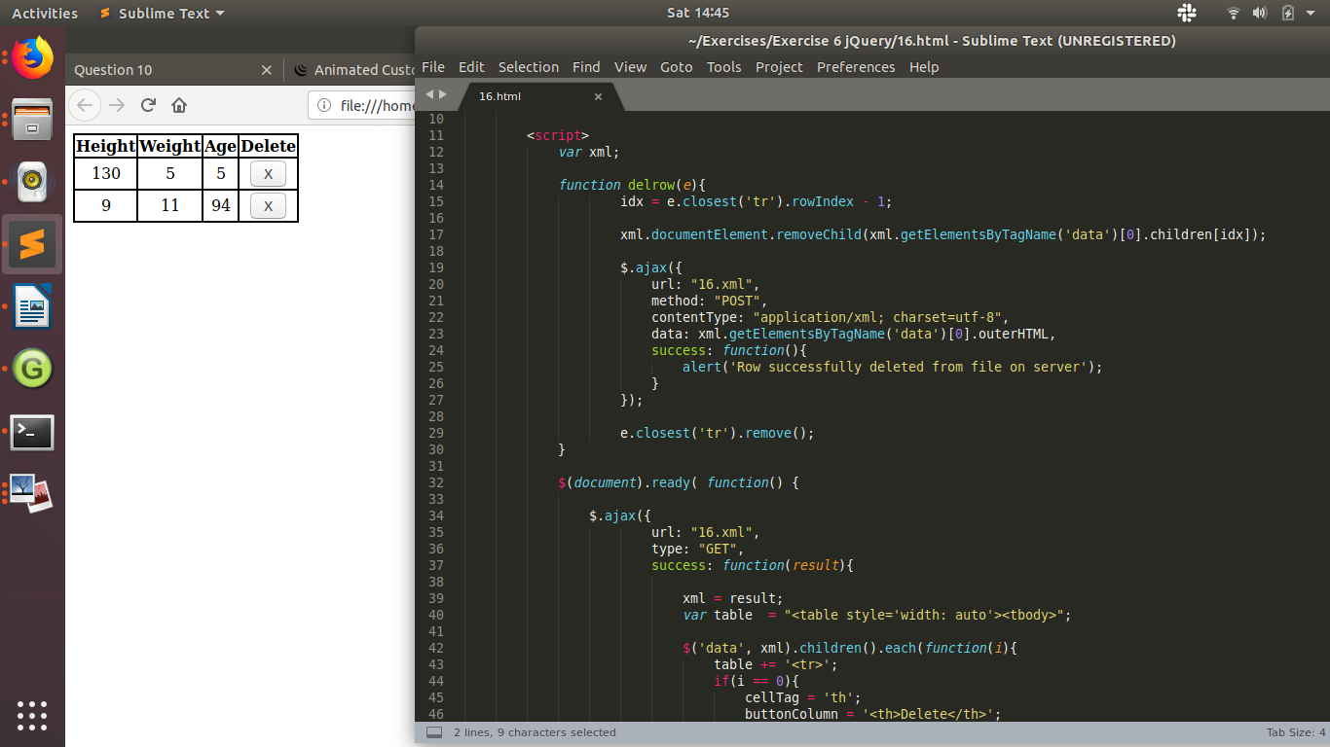
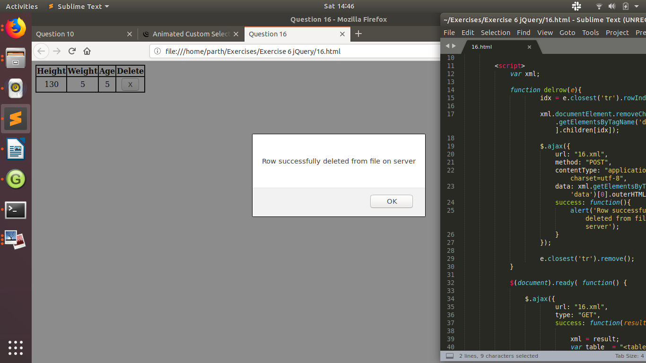

- Create a image array and in div create a slide show to animate images of delay of 500ms.
A17.
17.html
<html lang="en-IN">
<head>
<meta charset="utf-8">
<title>Question 17</title>
<style>img{opacity: 0; position: fixed; height: 300px; width: 300px;}</style>
</head>
<body>
<div>
<img src = "1.jpeg">
<img src = "2.png">
<img src = "3.jpg">
</div>
<script type="text/javascript" src="jquery.min.js"></script>
<script>
$(document).ready(function(){
var images = $('img');
imgarr = $.makeArray(images);
var i = -1;
setInterval(function(){
i = i < 2 ? i + 1 : 0;
$(imgarr[i]).animate({opacity: '1'}, 500, function(){
$(imgarr[i]).animate({opacity: '0'}, 500);
});
}, 1000);
});
</script>
</body>
</html>

